AI Assistant Coding Assignment-3.4
- Shashank || Batch-09 || 2303A51639
Lab 4: Advanced Prompt Engineering – Zero-shot, One-shot, and
Few-shot Techniques
Task 1: Zero-shot Prompt – Fibonacci Series Generator
Prompt: Fibonacci Series for first N numbers
Code:
def print_fibonacci(n):
"""Print the first N Fibonacci numbers."""
if n <= 0:
print("Please enter a positive number.")
return

a, b = 0, 1
print(f"The first {n} Fibonacci numbers are:")

for i in range(n):
print(a, end=" ")
a, b = b, a + b
print()

# Ask user to enter n value
if __name__ == "__main__":
try:
n = int(input("Enter the number of Fibonacci numbers to print: "))
print_fibonacci(n)
except ValueError:
print("Please enter a valid integer.")

Output:
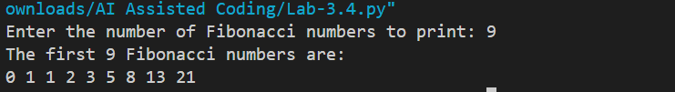
Task 2: One-shot Prompt – List Reversal Function
Prompt: generate function to reverse a list using slicing or loop.
Code:
def reverse_list_with_slicing(lst):
"""Return the reversed list using slicing."""
return lst[::-1]

def reverse_list_with_loop(lst):
"""Return the reversed list using a loop."""
reversed_lst = []
for item in lst:
reversed_lst = [item] + reversed_lst
return reversed_lst

if __name__ == "__main__":
user_input = input("Enter a list of items separated by spaces: ")
user_list = user_input.split()
print("Reversed list using slicing:", reverse_list_with_slicing(user_list))
print("Reversed list using loop:", reverse_list_with_loop(user_list))
Output:
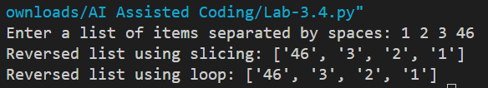

Task 3: Few-shot Prompt – String Pattern Matching
Prompt: write a function which checks if a string startys with a capital letter and ends with a period
Code:
def is_valid(text):
"""Check if a string starts with a capital letter and ends with a period."""
if len(text) == 0:
return False
return text[0].isupper() and text[-1] == '.'

if __name__ == "__main__":
user_input = input("Enter a string: ")
result = is_valid(user_input)
print(f"Valid: {result}")
Output:
Task 4: Zero-shot vs Few-shot – Email Validator
Prompt: write an email validation function using zero-shot
Code:
# Zero-shot email validation function
import re

def is_valid_email_zero_shot(email):
"""Validate email using a simple regex (zero-shot)."""
pattern = r"^[\w\.-]+@[\w\.-]+\.\w+$"
return re.match(pattern, email) is not None

# Few-shot email validation function with examples

def is_valid_email_few_shot(email):
"""Validate email using a regex and test with a few examples (few-shot)."""
pattern = r"^[\w\.-]+@[\w\.-]+\.\w+$"
if re.match(pattern, email):
return True
return False

# Few-shot examples
few_shot_examples = [
("test@example.com", True),
("user.name@domain.co", True),
("invalid-email", False),
("user@.com", False),
("@domain.com", False),
]

if __name__ == "__main__":
email = input("Enter an email address: ")
print(f"Zero-shot valid: {is_valid_email_zero_shot(email)}")
print(f"Few-shot valid: {is_valid_email_few_shot(email)}")
print("\nFew-shot test cases:")
for ex, expected in few_shot_examples:
result = is_valid_email_few_shot(ex)
print(f"{ex}: {result} (expected: {expected})")
Output:
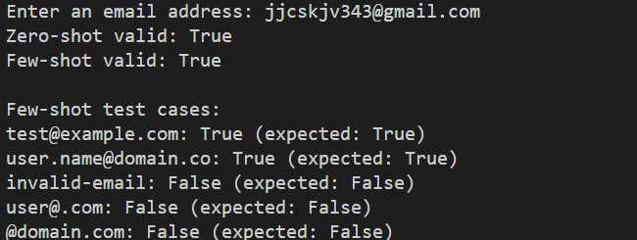
Task 5: Prompt Tuning – Summing Digits of a Number
Prompt: Generate two Python functions that return the sum of digits of a number
using two different prompt styles.
Style 1: Generic Task Prompt
- Write a Python function that returns the sum of digits of a given number.
Style 2: Task with Input/Output Example
- Write a Python function named sum_of_digits that takes an integer as input
and returns the sum of its digits.
Code:
# Style 1: Generic Task Prompt
def sum_of_digits_generic(num):
"""Return the sum of digits of a given number."""
total = 0
for digit in str(abs(num)):
total += int(digit)
return total

# Style 2: Task with Input/Output Example
def sum_of_digits(num):
"""
Return the sum of digits of a given number.

Example:
Input: 123
Output: 6
"""
return sum(int(digit) for digit in str(abs(num)))

if __name__ == "__main__":
test_number = int(input("Enter a number: "))
print(f"Sum of digits (Generic): {sum_of_digits_generic(test_number)}")
print(f"Sum of digits (With Example): {sum_of_digits(test_number)}")
Output:
